Blockchain Steganography using Hybrid Encryption

In this project as per your request we have implemented following modules

1. Input Message along with image: user has to input message along with image upload and number of chunks then application will divide message into given number of chunks.
2. For each chunk AES and DES keys will be generated
3. AES and DES is implemented to encrypt each chunk and the algorithm will be selected based on random values and AES and DES will encrypt message based on generate keys
4. RSA private and public keys will be generated where AES and DES keys will be encrypted using RSA and public key. AES and DES keys will be decrypted using RSA and its private keys
5. All encrypted chunks along with RSA keys will be embedded into image blocks using RESBC steganography and then RSA keys will be converted to SHA256 and then saved in Blockchain for future verification.
6. User can verify keys and can extract and decrypt text from steganography images.

To implement above functions we have designed following modules

1. User Register: using this module user can sign up to application
2. User Login: user can login to system
3. Upload Image: using this module user will enter Message, total chunks and upload image to application
4. Hybrid Encryption & Steganography: this module will perform all encryption and RESBC steganography on uploaded image and message chunks
5. Key Verification: sender or receiver will select desired image to verify its embedded keys hash with Blockchain keys hash and if both keys SHA hash matched then verification will be successful
6. Data Decryption: sender or receiver will select desired image and then application will decrypt and merge all chunks to form complete message.

Blockchain can store or retrieve data using Smart Contract which is designed using Solidity programming and this Smart Contract contains functions which can be called to save or retrieve data from Blockchain Ethereum. To manage keys hash we have designed following Smart Contract

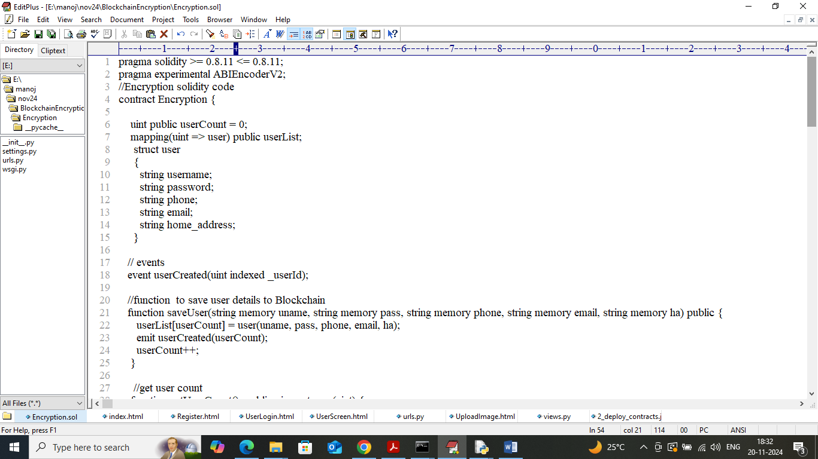

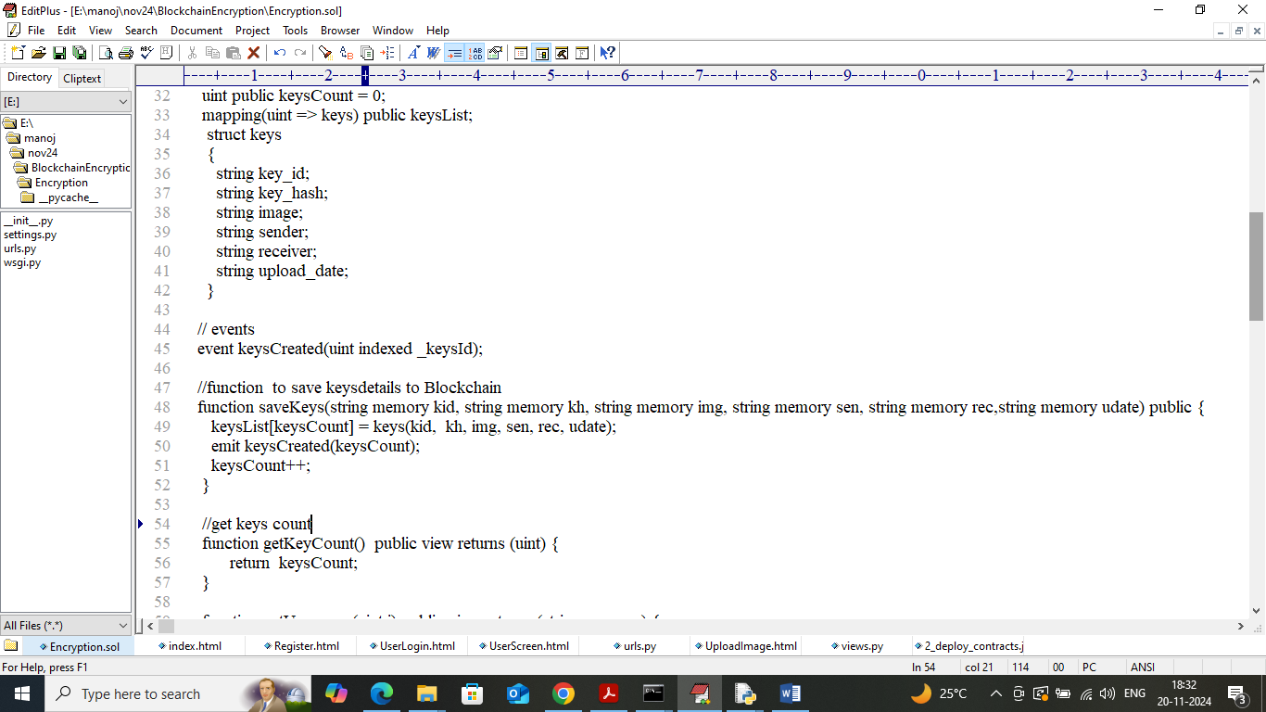

In above two screens Smart Contract code we have defined functions to save user details and encryption key hash details. Now we need to deploy above contract to Ethereum by following below steps

1. First go inside ‘hello-eth/node-modules/bin’ folder and then look and double click on ‘runBlockchain.bat’ file to get below page
2. 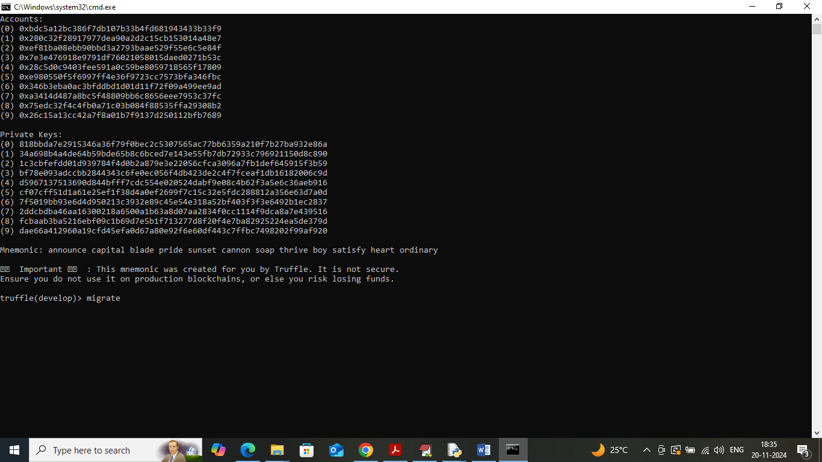
3. In above screen Ethereum started with default keys and accounts and now type command as ‘migrate’ and then press enter key to get below page
4. 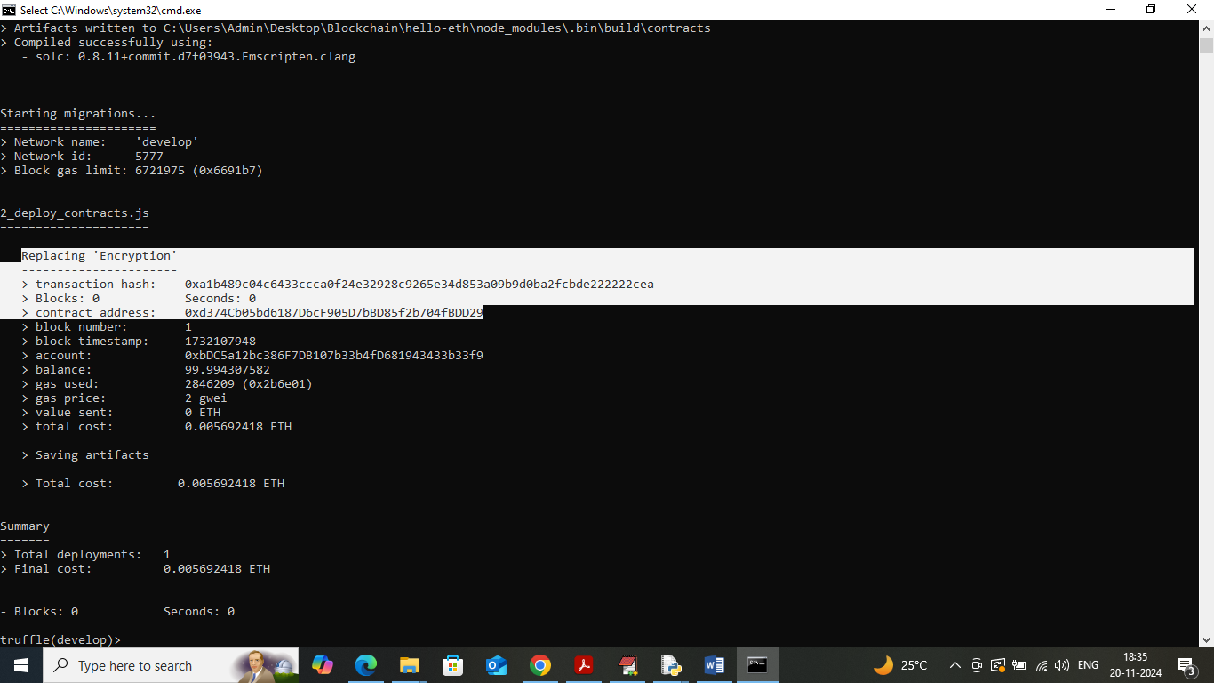
5. In above screen in white colour text can see ‘Encryption’ smart contract deployed and got contract address also and this address need to specify in python code to call above contract to save and get data.

In above screen contract deployed and running successfully and now click on ‘run.bat’ file to start python server and get below page

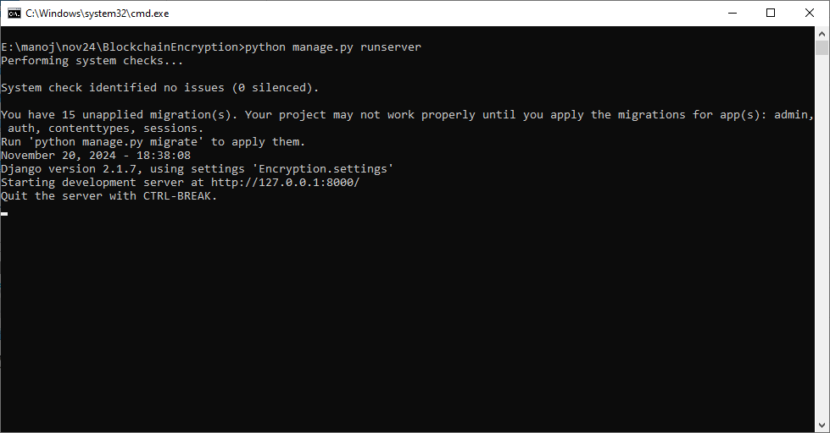

In above screen python web server started and now open browser and enter URL as <http://127.0.0.1:8000/index.html> and then press enter key to get below page

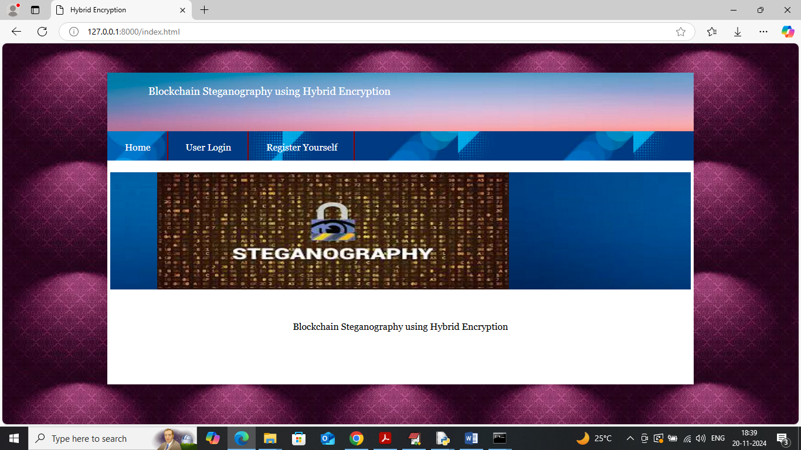

In above screen click on ‘Register Yourself’ link to get below page

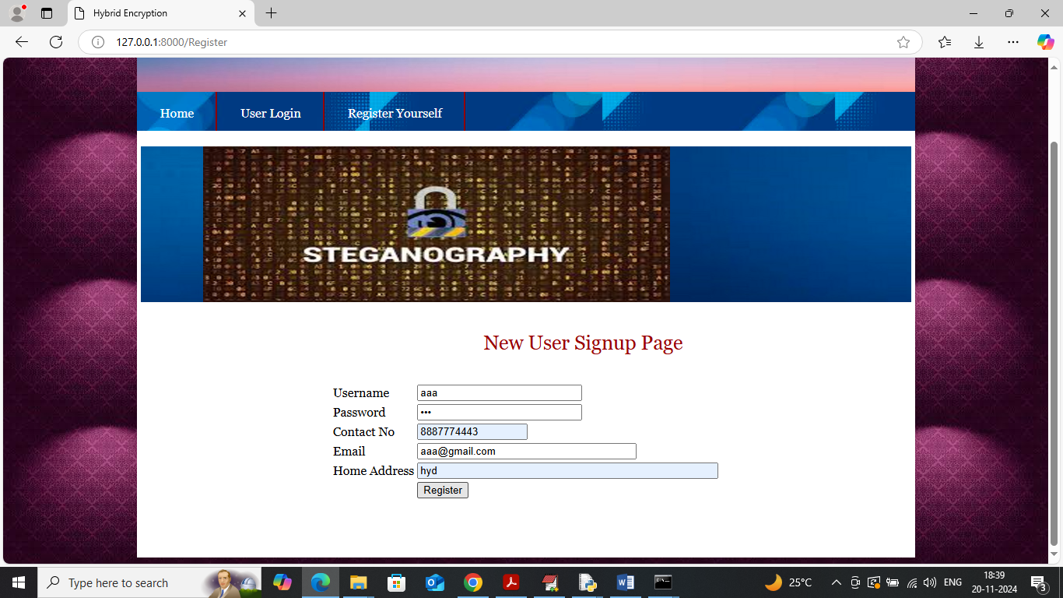

In above screen user is entering sign up details and then press button to get below page

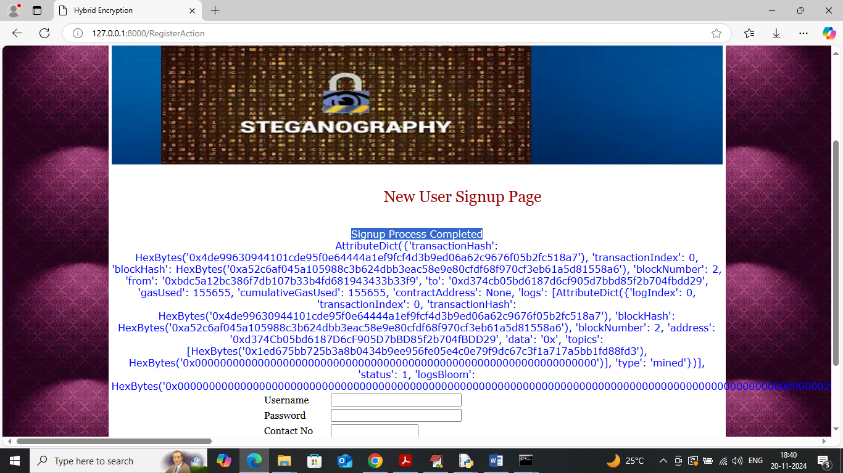

In above screen user sign up details saved in Blockchain and after storage Blockchain will send Proof of Work Log which contains details like Transaction no, block no, hash code and many other details and for your understanding purpose I am displaying entire log data. Similarly you can sign up any number of users. Now click on ‘User Login’ link to get below page

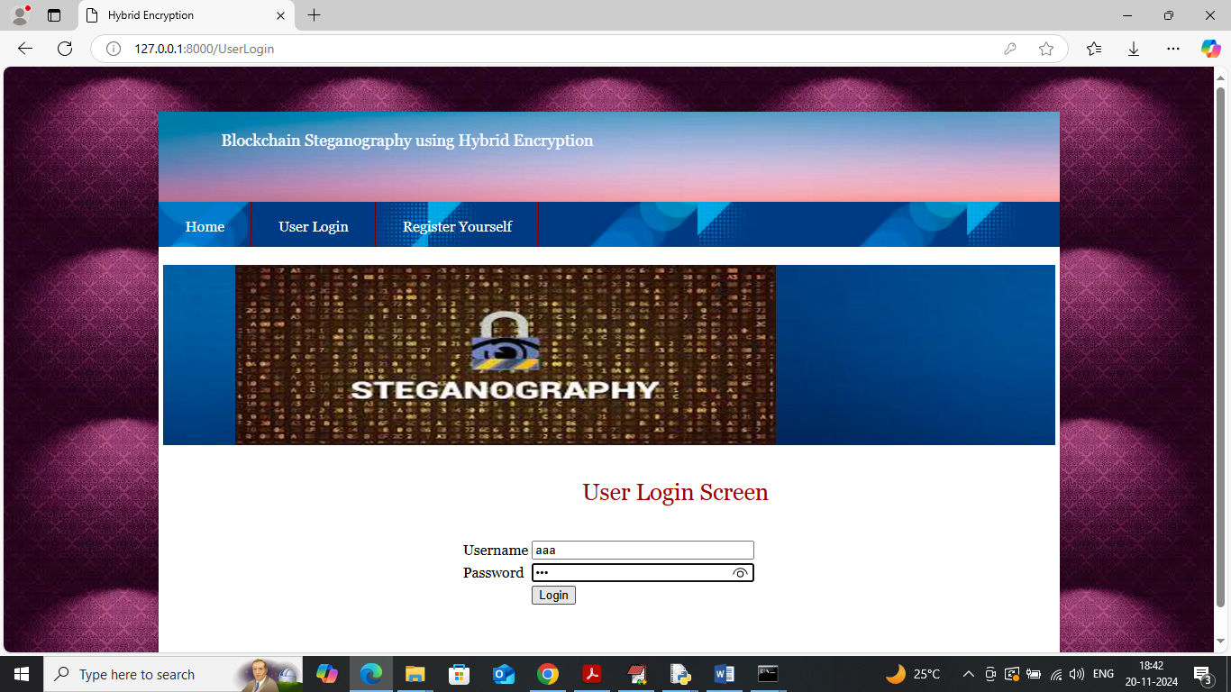

In above screen user is login and after login will get below page

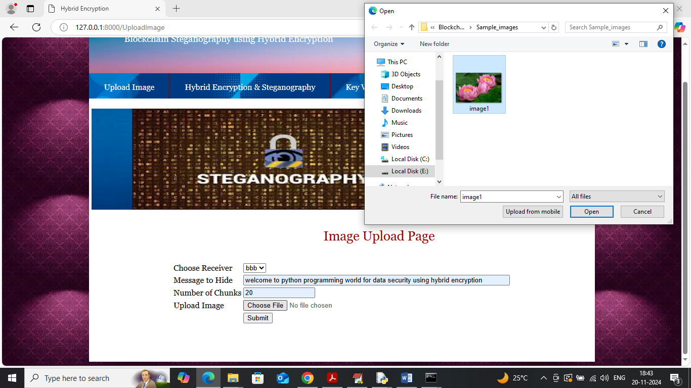

In above screen sender will select ‘receiver name, enter message along with chunks size and then upload image’ and then click on ‘Submit’ button to get below output

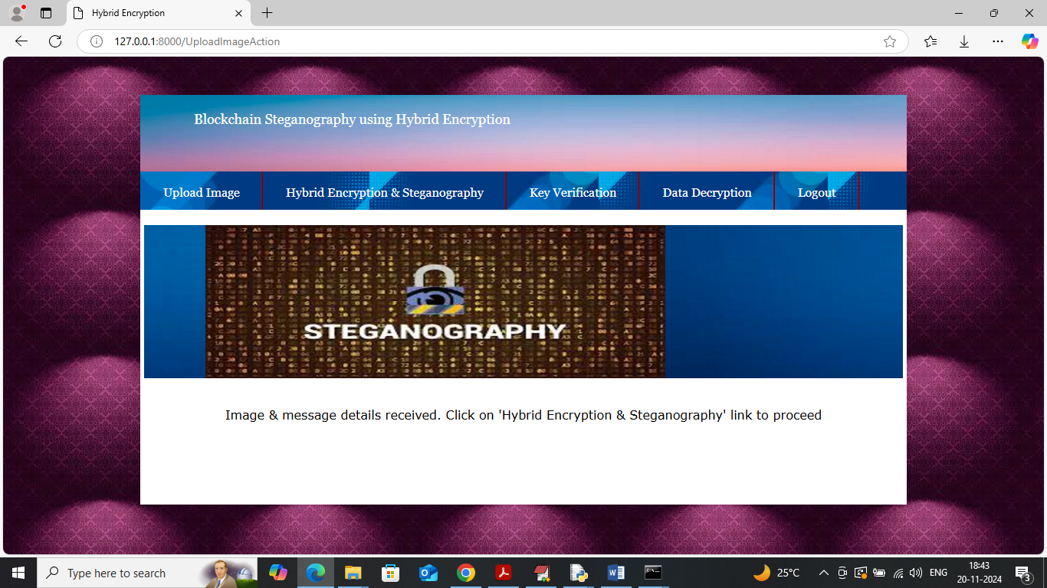

In above screen can see image and message successfully uploaded to application and now click on ‘Hybrid Encryption & Steganography’ link to perform encryption and steganography process and get below output

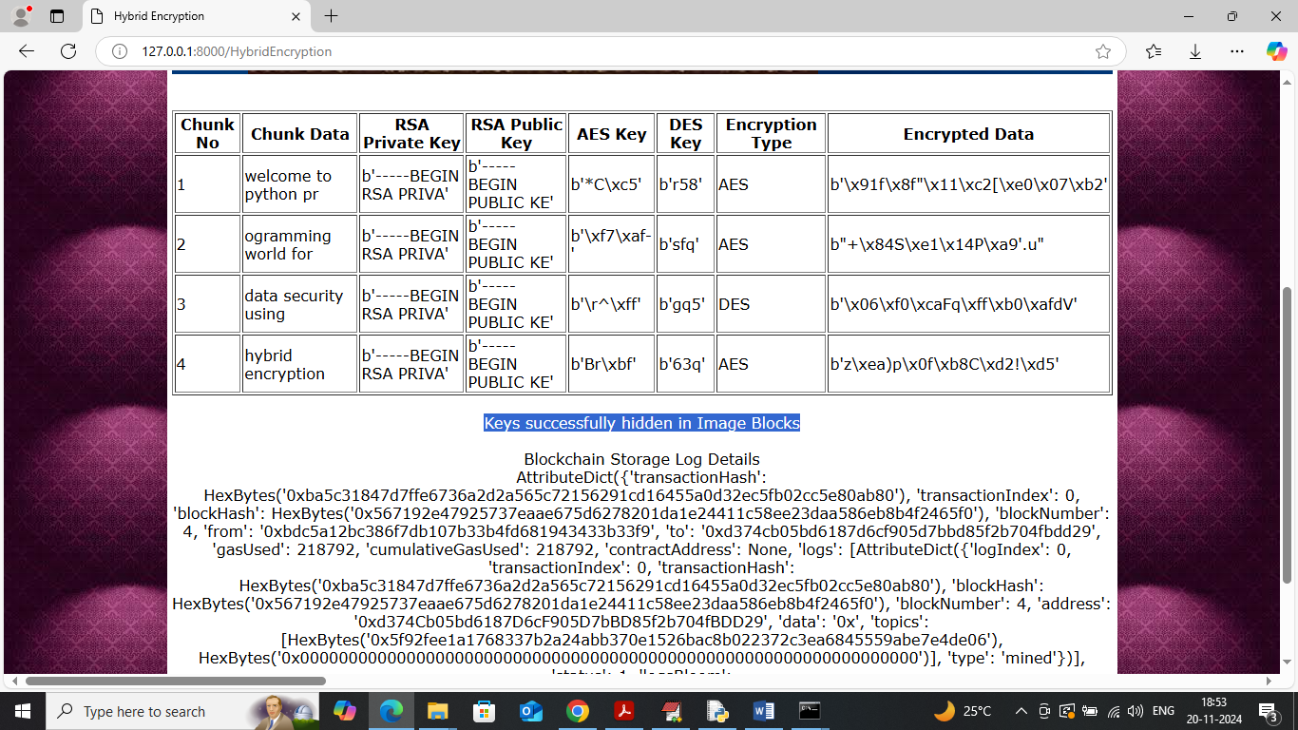

In above screen we can see total 4 chunks generated from given message and then can see all generated keys and can see algorithm name used to encrypt that chunk and then can see encrypted chunk data in tabular format. Below table we can see Blockchain log details after storing keys hash code and now click on ‘Key Verification’ link to get below page

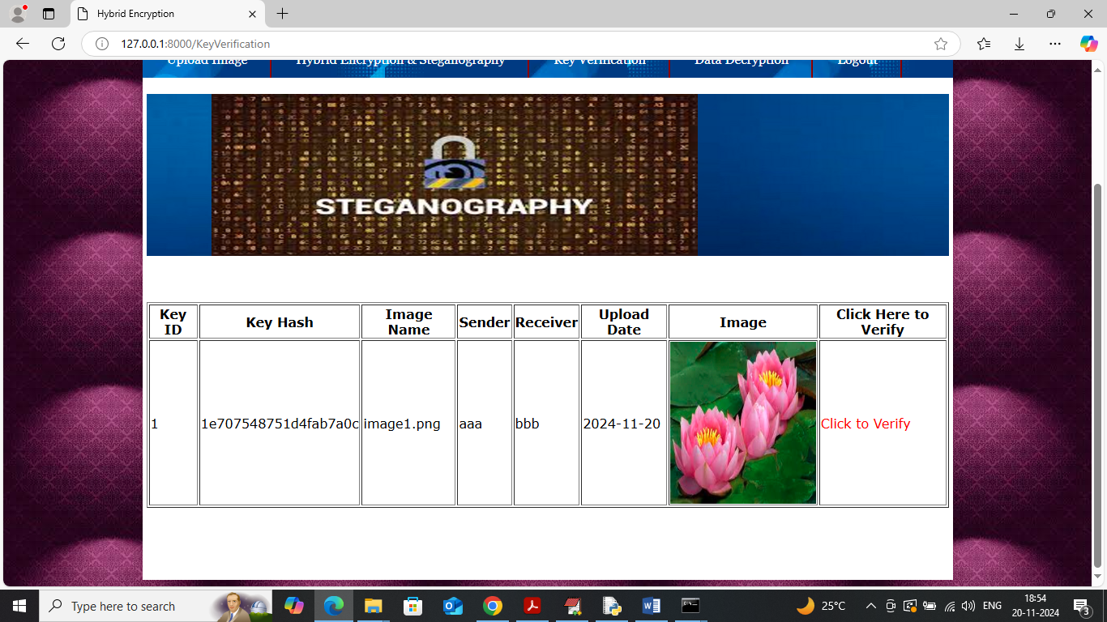

In above screen can see sender, receiver, hash code details obtained from Blockchain and now click on ‘Click to Verify’ link to get below page

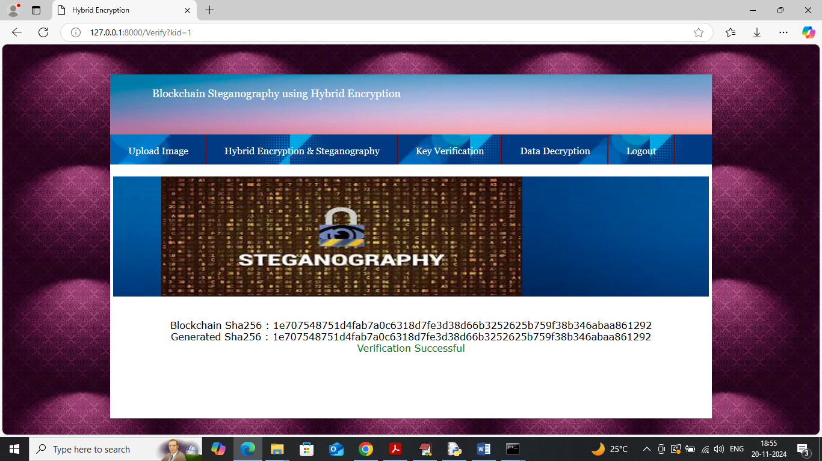

In above screen can see generated SHA code and Blockchain stored SHA code and both codes matches so verification successful. Now click on ‘Data Decryption’ link to view own and received images list like below page

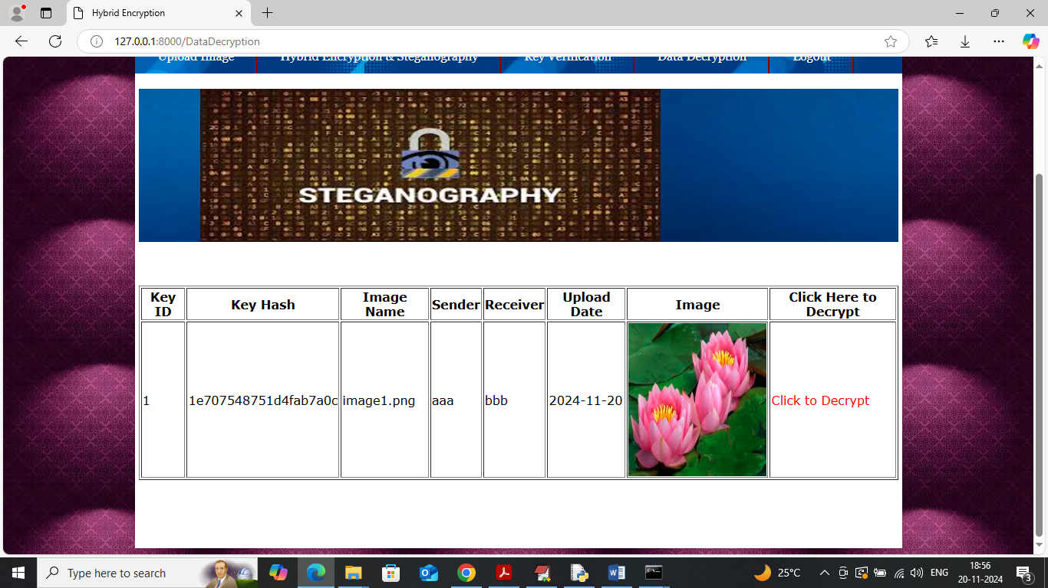

In above screen click on ‘Click to Decrypt’ link to get below page

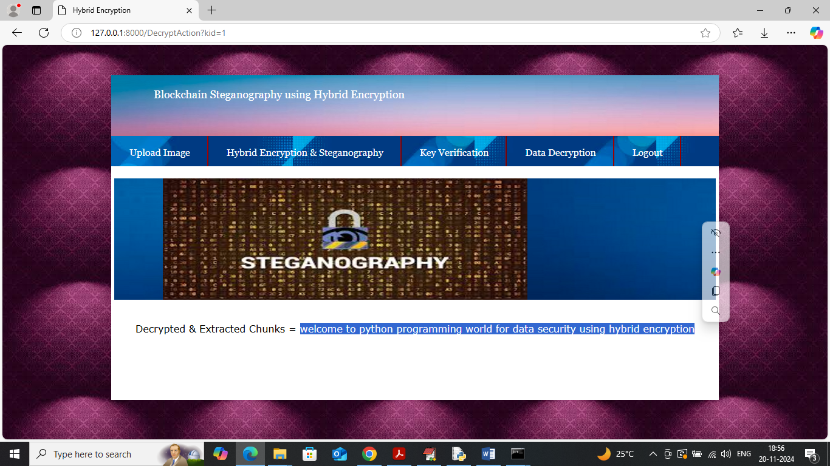

In above screen in blue colour text can see message successfully extracted and decrypted. Similarly by following above screens you can send and receive any number of images